|  |  |  |
| --- | --- | --- |
| **LAB 321 Assignment** | **Type:** | **Long Assignment** |
| **Code:** | **J3.L.P0010** |
| **LOC:** | **300** |
| **Slot(s):** | **10** |

**Title:** Student Request System – admin site

**Background**

Last assignment, you have done the student request system at user side, today we will make the admin side.

**Program Specifications**

Program a simple student request system on admin side, detail functions of this website is described below

**Features:**

This website contains 04 (four) main functions

* Function 1: Login page ( see figure 01)
* Function 2: Home page (see figure 02)
* Function 3: View requests page (see figure 03)
* Function 4: Solve requests page (see figure 04)

Note: All data must be load from database, not hard code.

***Expectation of User interface:***

Pic 01: Login Page ( TOP)

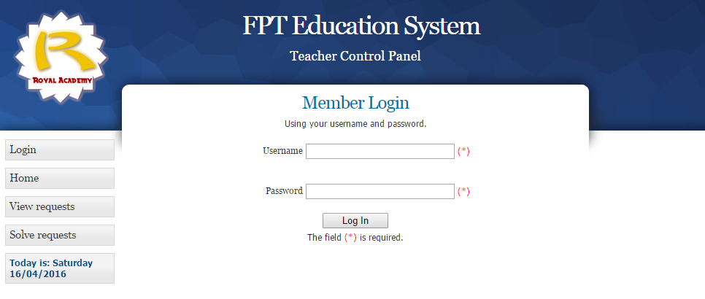

PIC 02: Home Page

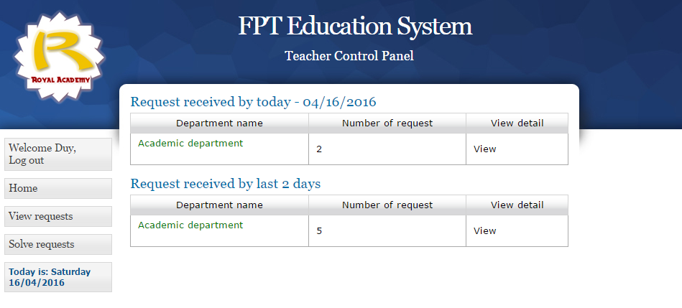

Pic 03: View requests Page

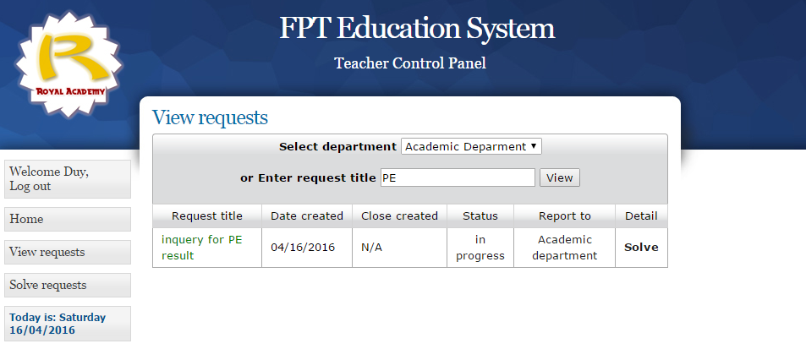

Pic 04: Solve request Page

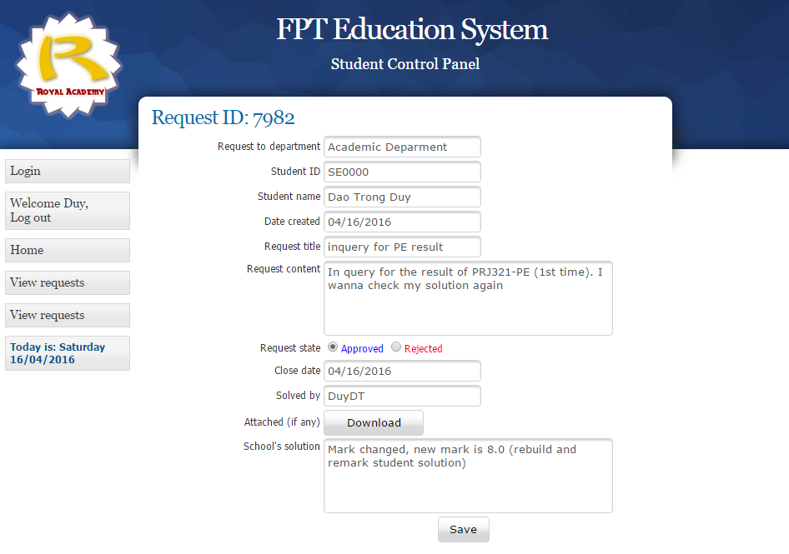

**Guidelines**

* Step 1 : Create prototype
* Step 2 : Design database base on created prototype
* Step 3 : Code & Test